Sandwich Meals
Served with a Side
Chopped Brisket - $21
Pulled Pork - $19
Smoked Sausage Link - $20
Smoked Chicken - $20
Jackfruit Sandwich (Vegetarian) - $20
Burger Meals
Served with a Side
1/4 Pound Angus Burger with American Cheese*-$17
Double 1/4 Pound Angus Burger with American*-$22
Cheeseburger with Bacon* - $20
BBQ Burger- Burger topped with BBQ Meat Choice*-$23

Fish and Chips Meal $19
Beer Battered Fish, Fries, and Slaw

Chicken Meals
Crispy Chicken Tenders and Fries $18
Crispy Chicken Sandwich and Fries $18

Mac and Cheese Bowls
Porky Mac - $19
Beefy Brisket Mac - $20
Sausage Mac - $19
Jackfruit Mac (Vegetarian) - $20
Chili Mac - $20
Chicken Mac - $20

Kids Plates (12 and under)
Comes with small fry and drink
Kids Pulled Pork Sandwich - $16
Kids Chicken Tenders - $15
Kids Mac and Cheese - $14

Sides
Seasoned Fries $8
Mac and Cheese $8
Mayo Coleslaw $7
Side Garden Salad $8
BBQ Beans $7

Large Garden Salad $15
Garden Salad – Chopped Lettuce, Shredded Carrot, Diced Red Pepper, Red Onion Slices and Cucumber Wedges, Dressings: Blue Cheese, Ranch, Vinaigrette
Salad Topped with Meat $20
Brisket, Pork, or Chicken

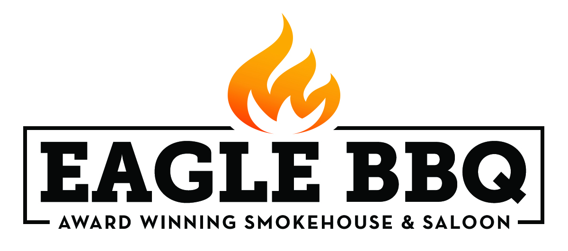
BBQ Platter Meals
½ lb. Meat per Serving, Served with a Choice of Side and Thick Cut White Bread
Smoked Pulled Pork
Smoked Andouille Sausage Links
Smoked Chicken
Jackfruit (vegetarian)
One Meat $21
Two Different Meats $30
Three Different Meats $38
_____________________________________________
Sliced Brisket
St. Louis Ribs
One Premium Meat $24
Two Premium Meats $35
Three Premium Meats $47
*brisket and rib pricing as noted, double and triple orders additional

Smoked Meat by the Pound
Brisket $29, Rack Ribs $36, ½ Rack Ribs $20, Pulled Pork $22, Sausage $22, Chicken $22
½ pound $15, ½ pound brisket $16

Beverages
Fountain Soda $4
Gatorade Bottle $6
Aquafina Bottled Water $3

Soups
Served with cornbread or crackers
Brisket Chili $15

Sweets
Cookie $4
Brownie $5
Sweet Potato Pie $5
Cheesecake $5
Pecan Pie $5

Call 970-367-5007
www.whiskeyandbbq.com
Or Email: Theeaglebbq@gmail.com
Prices do not include tax
Not all items are available at all times, we do occasionally sell out.
*Consuming raw or undercooked food may increase risk of foodborne illness

